Comparison of Region Based on Sales

Data Analyst
Tableau

Description
The director of a leading organization wants to compare the sales between two regions. He has asked each region operators to record the sales data to compare by region. The upper management wants to visualize the sales data using a dashboard to understand the performance between them and suggest the necessary improvements.

Objective: Help the organization by creating a dashboard to visualize the sales comparison between two selected regions.
Datasets: Sample Superstore

Steps to Perform:
- Select Sample Superstore as Dataset
    - Use Sample Superstore Dataset
    - Select Data
    - Use Group by from Data Source Table on a Folder to create a folder to segregate the required data for Customer Name and Order ID in order to organize the data thoroughly.
- Create a hierarchy called Location for the variable Country.
- Create two parameters: Primary Region and Secondary Region with all regions listed in them. Here, primary and secondary region are the two regions where the sales are being compared.
    - Create Parameters for Primary Region and Secondary Region
    - Create a Calculated Field for both Primary Region and Secondary Region
- Create a First Order Date
    - Create a Calculated Field and name it as the First Order Date
- Create a dashboard
    - Align all sheets in the dashboard
- Partition the dashboard to display the below details of Primary Region and Secondary Region
- First Order Date
- Total Sales
- Average Sales per Order
- No. of Customers
- No. of Orders
- No. of Products in Sale

Solution:
Step 1: Use Sample Superstore Dataset
- Select Data
- Use Group by from Data Source Table on a Folder to create a folder to segregate the required data for Customer Name and Order ID in order to organize the data thoroughly.
Output:

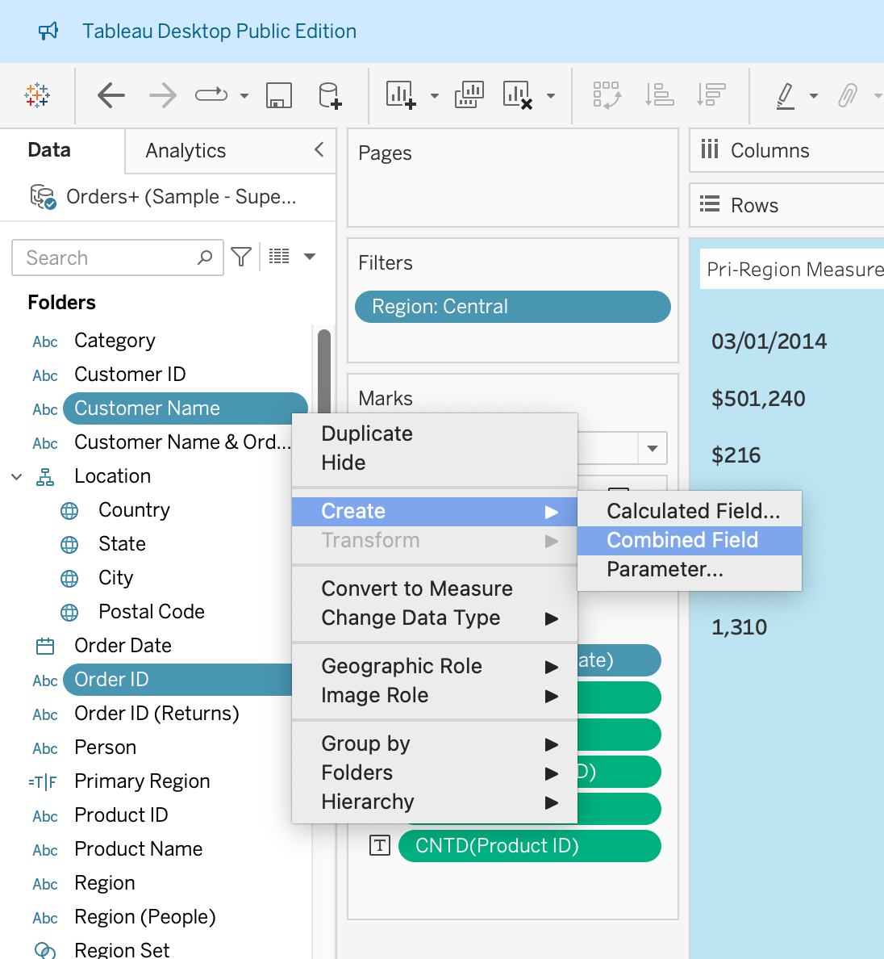
Step 2: Create a hierarchy called Location for the variable Country.
Output:

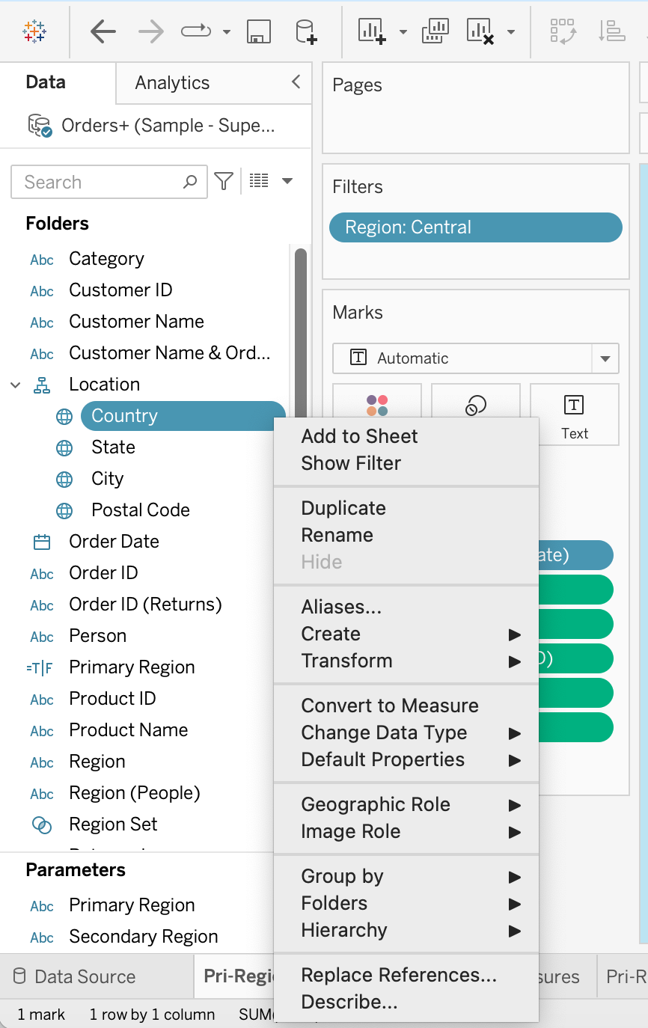
Here, we have created a hierarchy by right clicking on Country and then add State, City and Postal Code to the hierarchy which we have named ‘Location’.

Step 3: Create two parameters: Primary Region and Secondary Region with all regions listed in them. Here, primary and secondary region are the two regions where the sales are being compared.
- Create Parameters for Primary Region and Secondary Region
- Create a Calculated Field for both Primary Region and Secondary Region
Output:
Here, we have considered the Central Region as the Primary Region and the East Region as the Secondary Region by placing the ‘Region’ over the filter option and choosing accordingly.
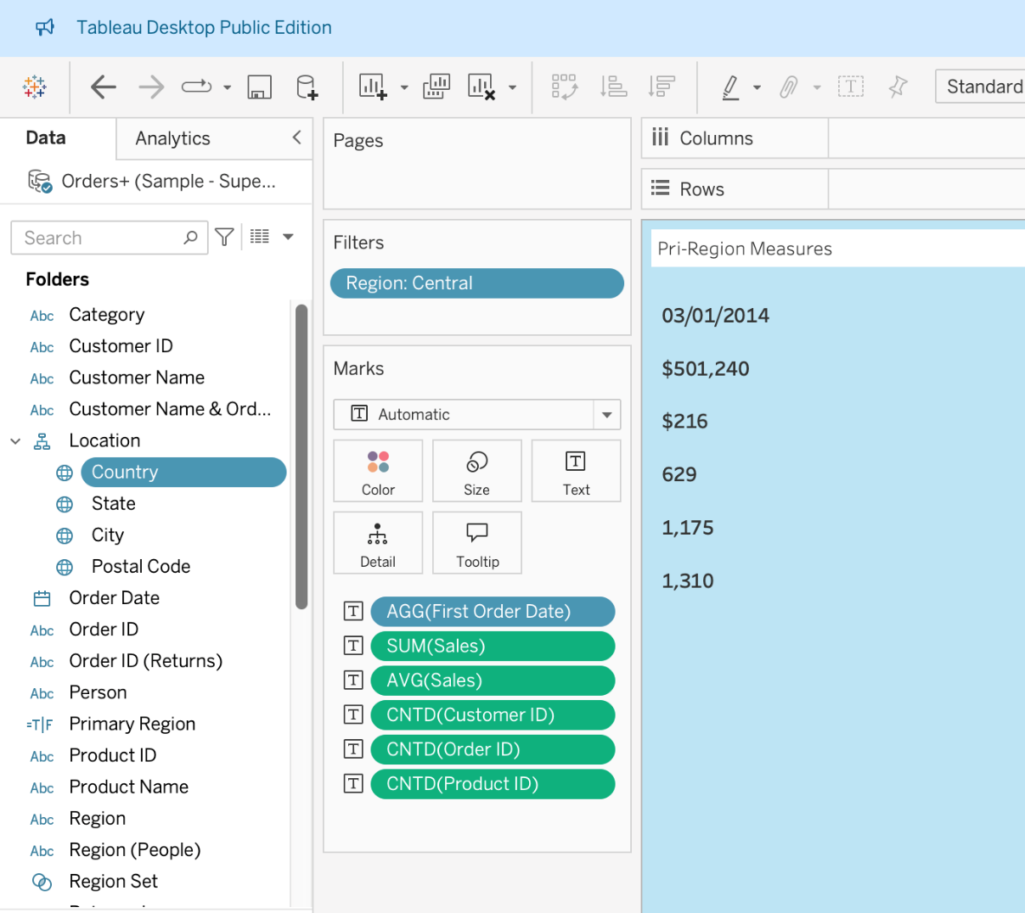

Then we have created two parameters for Primary Region(Central) and Secondary Region (East) simultaneously:
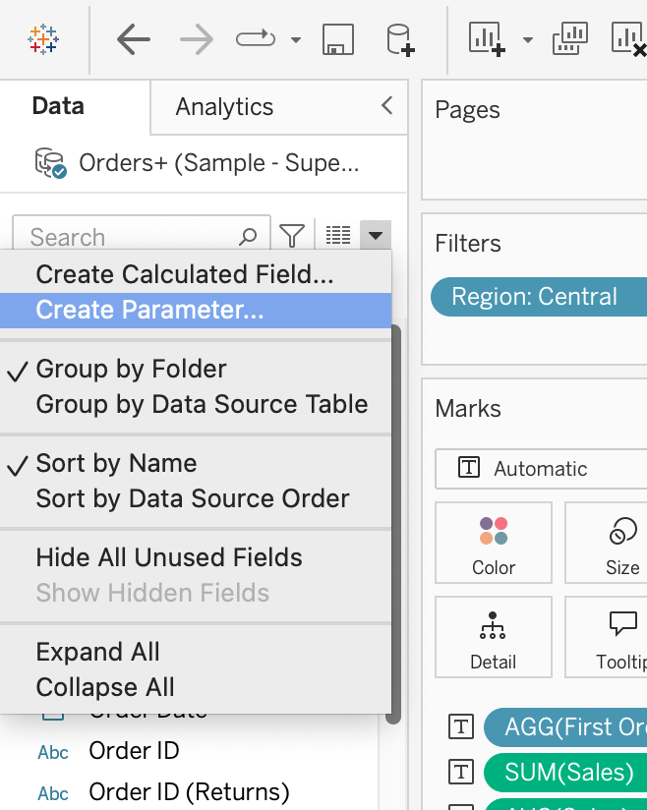
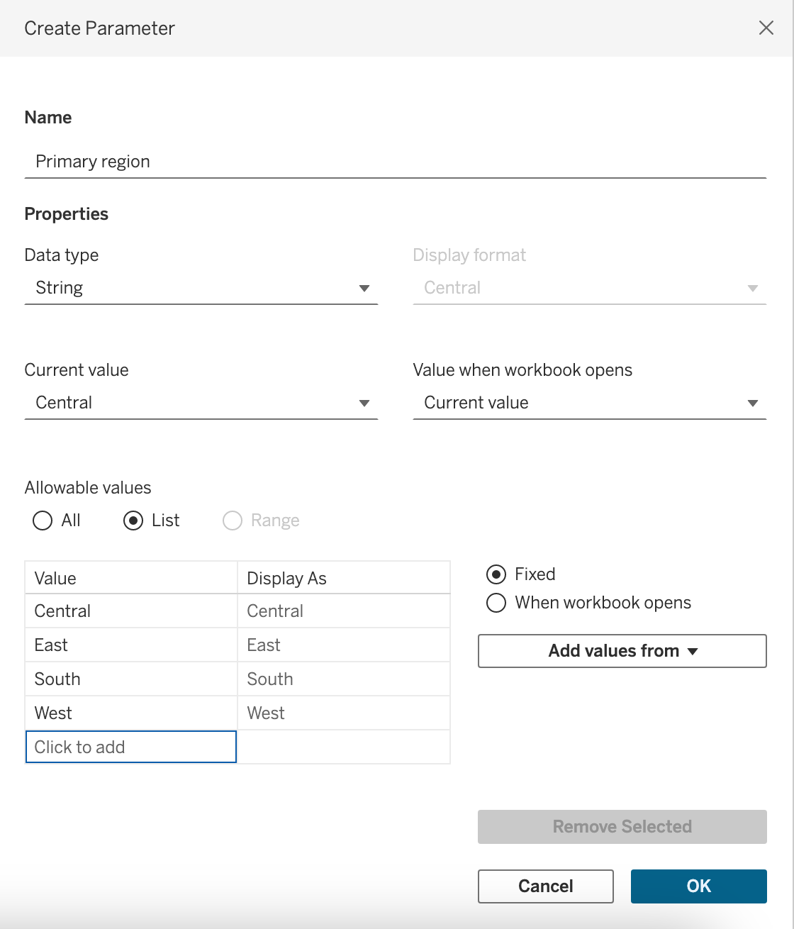

Then, we have created calculated field for both Primary Region(Central) and Secondary Region(East).
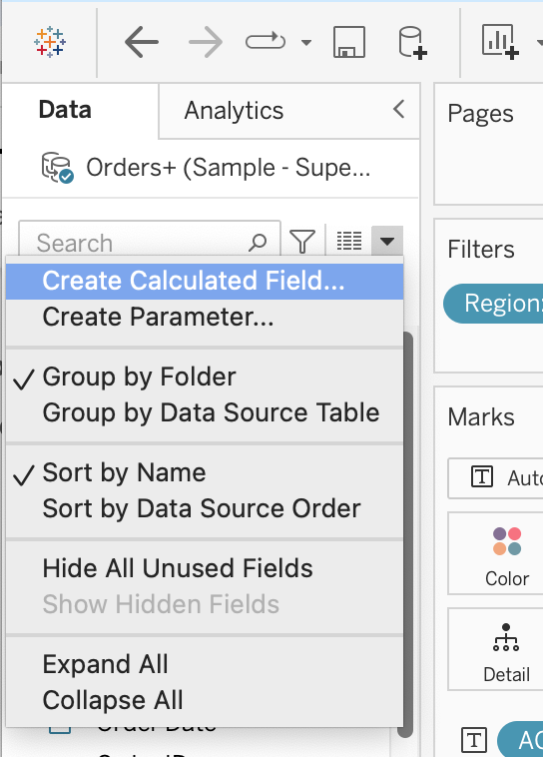
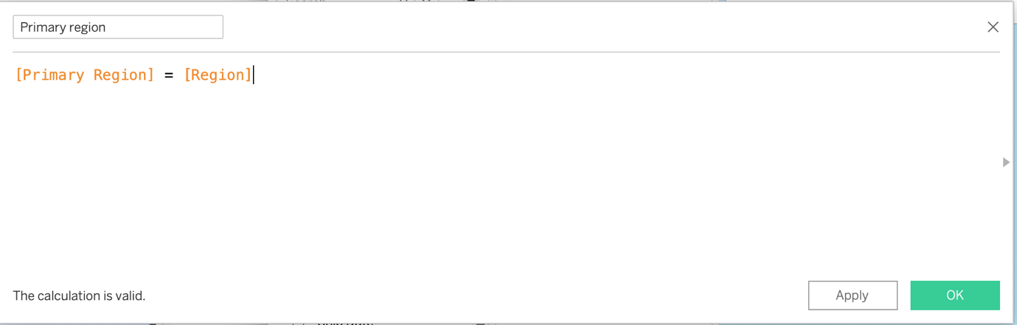

Step 4: Create a Calculated Field and name it as the First Order Date
Output:
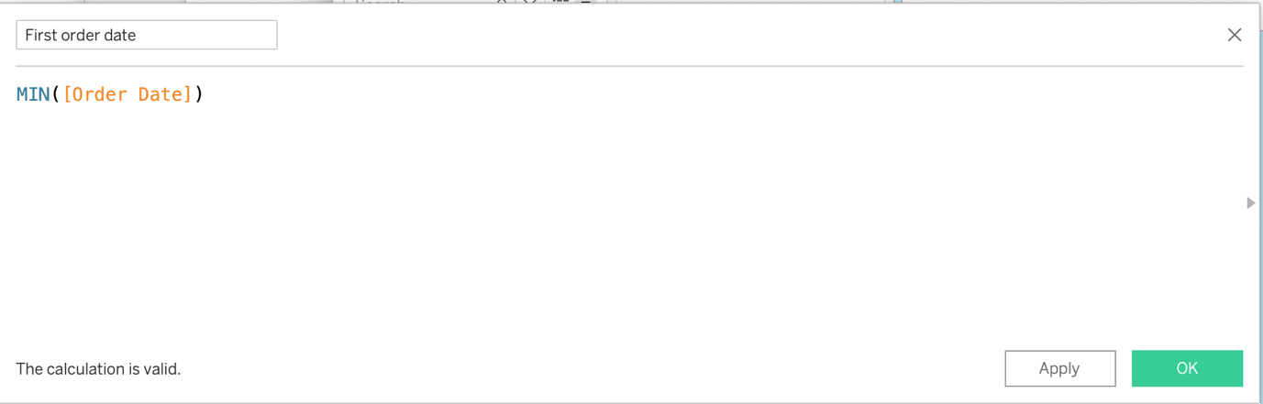

Step 5 and 6: Create a dashboard and align all the sheets.
- First Order Date
- Total Sales
- Average Sales per Order
- No. of Customers
- No. of Orders
- No. of Products in Sale
Output:
We have created below charts according to given conditions for both regions:

Central Region:
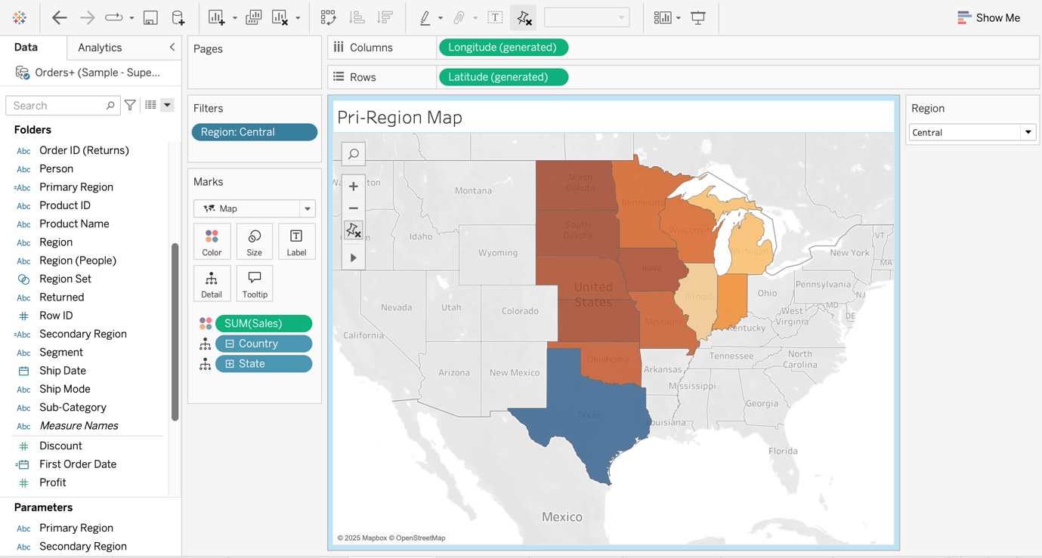

East Region:

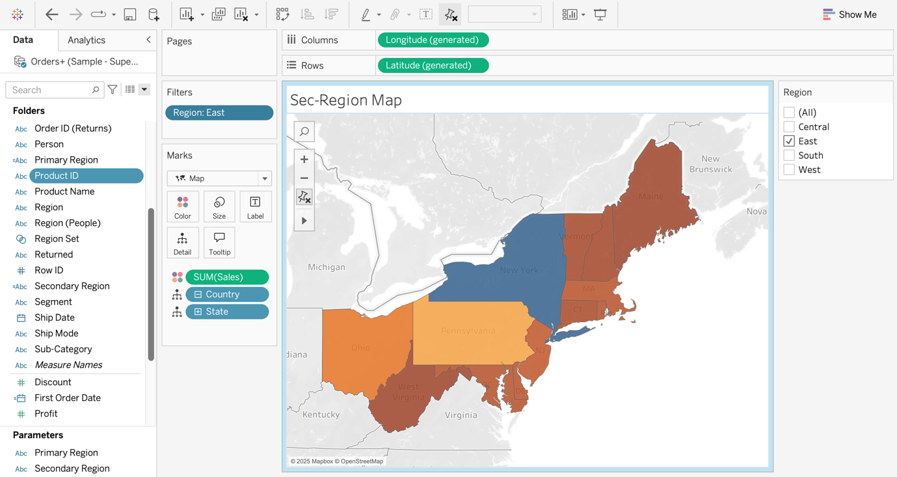

Sub-Category wise Sales (Central Region):
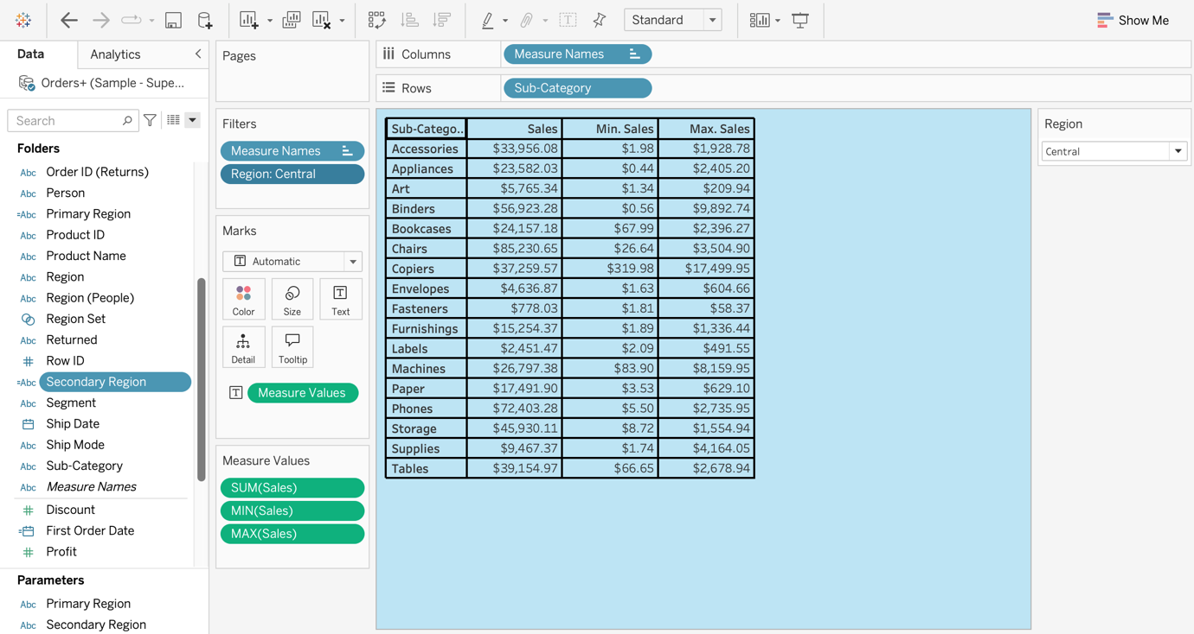

Sub-Category wise Sales (East Region):
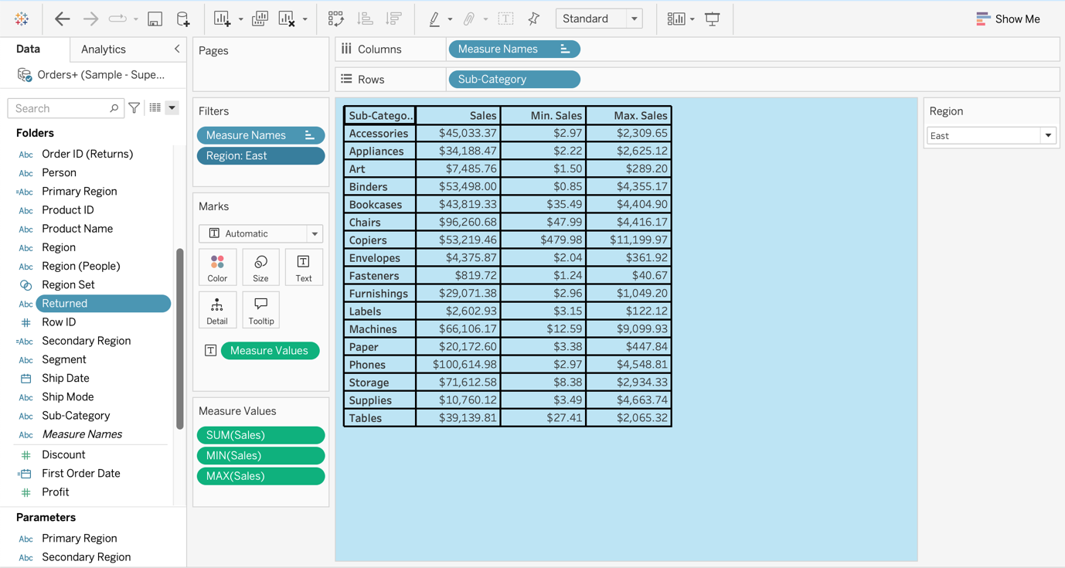

Sub-Category wise Monthly-Sales (Central Region):
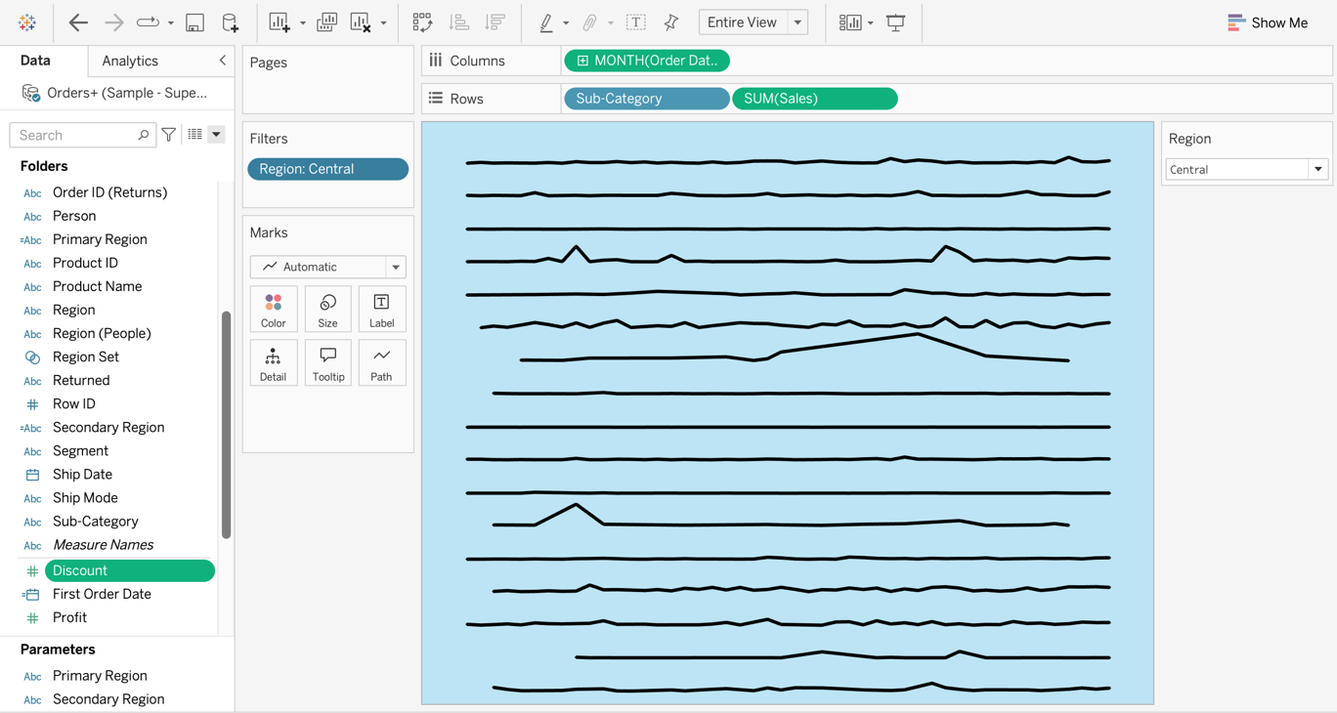

Sub-Category wise Monthly- Sales (East Region):

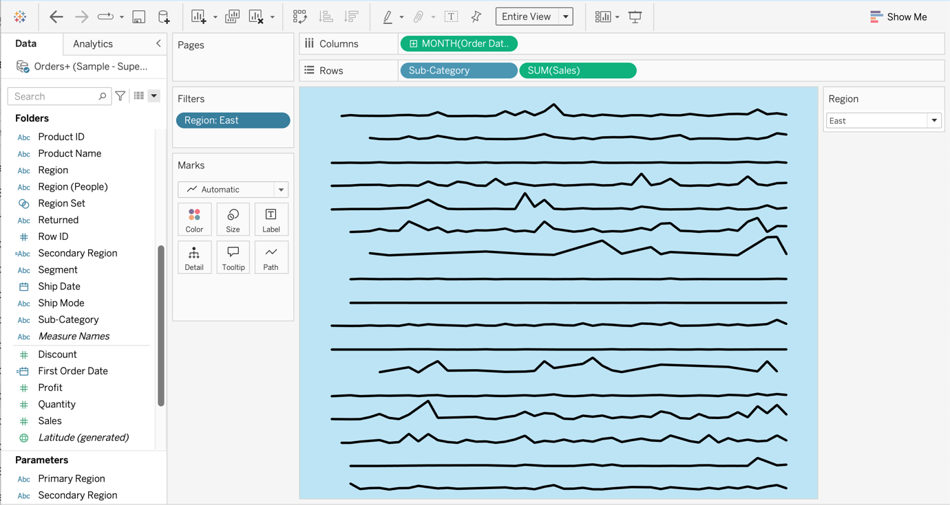

Final Dashboard:

